User Guide 18 Responsible Authority hosted applications in SPEAR
Purpose of this User Guide
The purpose of this User Guide is to provide advice to Responsible Authorities wishing to submit or host applications in SPEAR on behalf of applicants who have submitted paper applications to a Responsible Authority. Hosting is mainly done to access the benefits of doing referrals in SPEAR.
Who should read this?
Primary audience: Responsible Authorities (only available to Local Government Authorities)
For information: Applicants and referral authorities
Introduction
To host an application on behalf of an applicant, the Responsible Authority user must have the ‘3rd Party Applicant’ role selected in their user profile settings. This can be done by either a Local Administrator or the SPEAR Administrator. Once enabled, the Responsible Authority user will be able to change their role to ‘3rd Party Applicant’ in SPEAR.
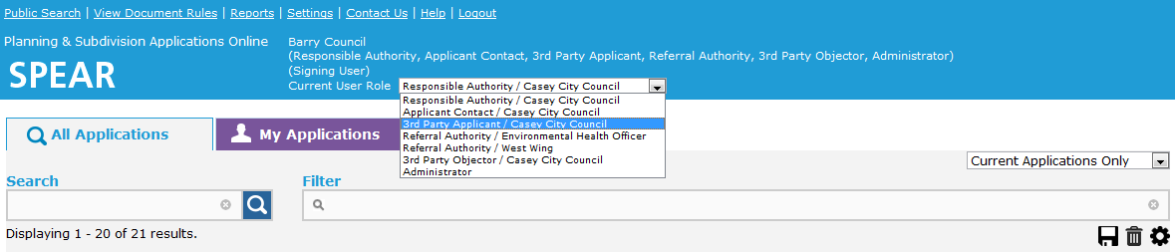
To change roles within SPEAR, login and click the ‘Current User Role’ drop-down list located in the SPEAR banner and select the required user role. All roles displayed in this list are determined by the user profile settings that the Local Administrator or the SPEAR Administrator set.
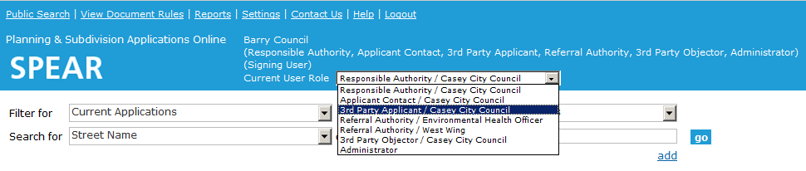
Selecting the ‘3rd Party Applicant’ role
Whilst performing the role of a ‘3rd Party Applicant’, the Responsible Authority user will be able to access applicant functions in SPEAR, except for digitally signing documents (plan of subdivision, abstract of field records and surveyors report).
Typically, a hosted application is processed in SPEAR as far as ‘Certification Decision Pending’. The final certification decision and Statement of Compliance (SOC) are issued on paper and returned to the surveyor for lodgment at Land Use Victoria.
To revert to the regular Responsible Authority role, the user must select the ‘Responsible Authority/…’ role from the list.
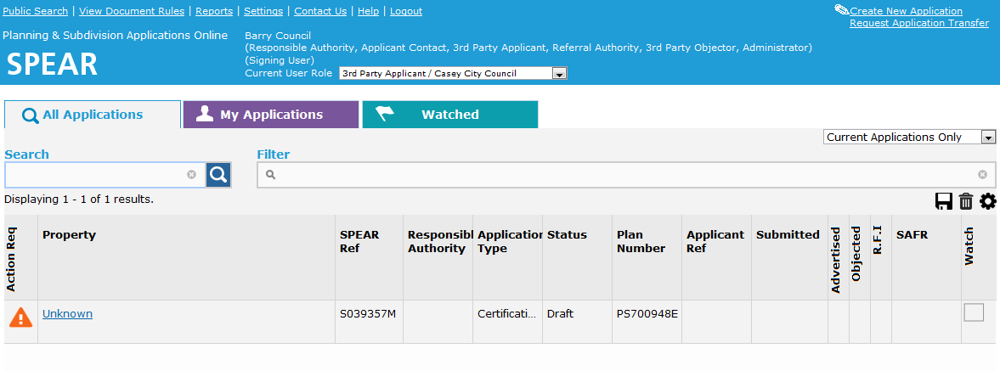
NOTE: To process a hosted application through to completion, it will be necessary to switch roles between ‘Responsible Authority’ and ‘3rd Party Applicant’ to complete all the required actions.

‘3rd Party Applicant’ view of SPEAR.
18.1 Creating an application as a 3rd party applicant
A paper application is received by the Responsible Authority from a non-SPEAR applicant.
The Responsible Authority decides to host the application in SPEAR. The paper documents submitted by the applicant need to be scanned and saved as PDF’s in preparation for loading into SPEAR.
Responsible Authority user can change their role to ‘3rd Party Applicant’ and click the Create New Application link located in the top right-hand corner of the applicant view.
See User Guide 1 Creating an Application, for directions on the steps required to create a new application.
NOTE: When completing the Application & Owner details:
Applicant Details - will default to the Responsible Authority’s user details
Applicant - insert the application contact details e.g. surveyor, developer etc.
Owner - insert the details of the owner
* Applicant and owner details above are a guide only.
18.2 Processing and completing a hosted application
Issues that a Responsible Authority should be aware of when hosting an application in SPEAR include:
The digital signing of plans by the licensed surveyor is not possible, as the surveyor is not a SPEAR user. A final signed version of the plan must be supplied by the surveyor (heavyweight plans).
Any correspondence required between the Responsible Authority and surveyor, will need to be made outside of SPEAR.
Any correspondence required between the referral authorities and the applicant will need to be made outside of SPEAR care of the Responsible Authority. The Responsible Authority should manage any additional information requests made by other parties through SPEAR and ensure that the applicant is aware of the requirements.
Any new plan versions will be received in paper form, from the applicant. The applicant’s plans and any other documents will need to be scanned by the Responsible Authority and loaded into SPEAR for the benefit of the referral authorities, and if re-referral is required.
Final certification and SOC need to be issued on the heavyweight plans/forms (manually signed) and returned to the applicant in paper.
Paper plans will be lodged at Land Use Victoria for registration.
The lodgment process remains unchanged; the lodging party/solicitor acting for the client will submit all the required paper documents at the time of lodgment.
To finalise a hosted application in SPEAR, select the option ‘Complete Hosted Application’ from the optional action drop-down list and click ‘go’. The application will be sent to the completed list.

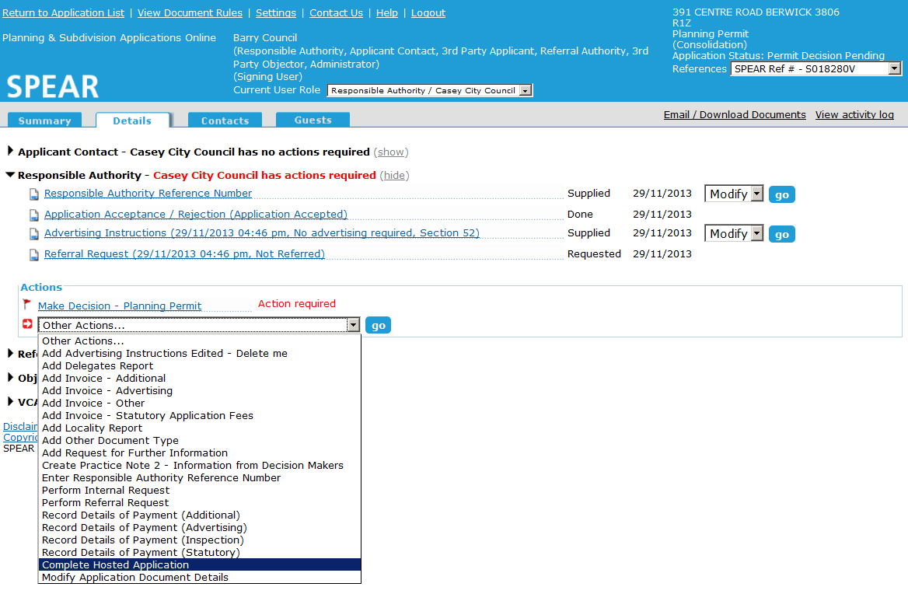

18.3 Benefits of hosting an application in SPEAR
Convenience of electronic referrals
Speed of delivery of referral requests and responses
Ease of tracking referrals in one application.
As a means of demonstrating and introducing to non-SPEAR Applicant Contacts some of the benefits of joining SPEAR.
Where to get more information
Further information on this topic can be found by:
- Visiting the SPEAR website at www.spear.land.vic.gov.au/SPEAR/
- Contacting the SPEAR Service Desk on 9194 0612 or email spear.info@delwp.vic.gov.au

